Type of storage systems :

Object - provided by cloud storage service

Instance - provided by persistent disk

Blob provided by persistent disk

database - sql , nosql , analytic .

**Managed databases :**

Cloud sql - relational database

Cloud spanner - relational

Nosql - datastore - document type , firestore - , bigtable - wide column

Bigquery - analytic - used for data warehousing and data analysis

**Cloud storage : it has a global namespace . bucket**

Unstructured data - image , video , test , archive data

Temporary storage between services , global / web access , internet accessible .

Different storage classes - (read and modify once in mentioned time )

standard - frequently accessing data , optimized for performance ,

Backup and archival

Nearline - stored for 30 day

Coldline - stored for 90 day

Archive -stored for 365 day

Structure : bucket > folder > object

**Redundancy : highly durable**

Regional storage - in single region , replicate in zone

Dual region - data replicated across a specific pair of regions , auto failover .

Multi region - highest level of redundancy , dta replicate in multiple region

**Cloud storage support object lifecycle management :**

Automatic transition to lower cost storage class , specify lifecycle policy , retention policy specify minimum retention period , object holds prevent deletion so no one can delete it .

**security :**

Automatic encryption - data stored in gcp is encrypted .

Google managed key .

Customer managed key - use cloud key managed service

Customer supplied key - use key created and managed by customer

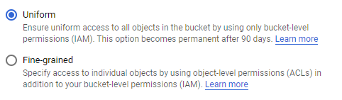

Accessing object :

We have bucket level access where we can use access control lists, or we can use IAM privileges to control access to objects.

Also, cloud storage keeps track of activity and logs that kind of activity into data access logs. As well as different kinds of operation logs,

Versioning and object lifecycle management :

If we wanna move objects from regional storage to Nearline storage after 30 days, we can create a policy to do that automatically, and we do that because it'll help us save money 'cause Nearline storage costs less than regional or multiregional storage.

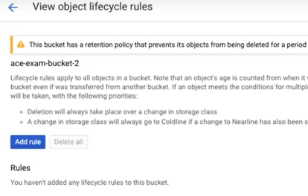

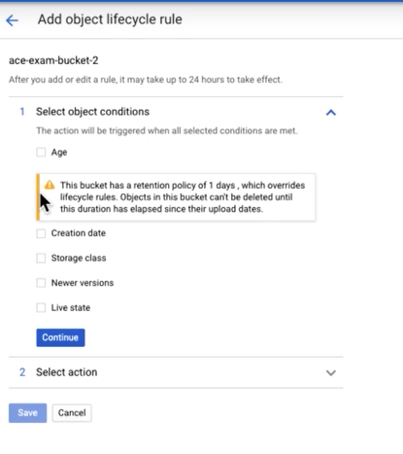

We can add lifecycle policy , condition and action .

Coldline can't be moved to nearline

We can add conditions, age or version . and specify action for that condition.

**Managed sql databases :** suited for structure data

Relational :

Structured database , required sql , acid transactions , complex query , joins .

Cloud sql - postgre my sql (unto 10 tb and regional )

Cloud spanner - horizontally scalable , global expensive .

**Managed nosql database :**

Nosql database :

Semistructured , flexible schema , no joins .

Datastore / firestore - json db , document , hierarchy

Bigtable - petabyte wide column , low latency writes , analytics .

Analytic db : bigquery for data warehouse , petabyte scale , sql , not transactional .

Cloud SQL and Cloud Spanner are managed relational databases. Cloud Datastore is a NoSQL database and BigQuery is an analytics database, although, like relational databases, it uses SQL as a query language.

Cloud Datastore is a NoSQL document data store.

The first thing to try is multi-regional storage which will distribute copies of data to multiple regions. Requests for that data will be routed to the nearest location where it is stored. Nearline storage is for data accessed less than 1 per 30 days. Cloud Memorystore is for frequently accessed data, typically from databases not large objects such as videos. Bigtable is a wide-column NoSQL database suitable for applications requiring low latency writes, like IoT, or large volume analytics.

using lifecycle management policies because object storage is modified based on age. You could write a script for this task but that would take longer to implement and would have to be maintained. Data retention rules are used to ensure files are not deleted before some period of time has passed.

Access is granted to Cloud Storage objects using IAM or access control lists (ACLs). When uniform bucket-level access is applied, users only have access through IAM roles and permissions. A user that could access objects before uniform bucket-level access is applied but not after must have had access through ACLs.

The correct command for changing the storage class is gsutil rewrite with the target storage class and bucket specified.

Nearline Storage is a class of Cloud Storage designed for objects that will be accessed at most once every 30 days. Coldline Storage is suitable for objects accessed at most once per year. Multi-regional storage is best suited for objects that should have low latency access from multiple regions. Persistent disks should not be used for archival storage.